1. Download and install Ubuntu

<http://releases.ubuntu.com/14.04/>

2. Download Eclipse CPP

<http://www.eclipse.org/downloads/download.php?file=/technology/epp/downloads/release/helios/SR2/eclipse-cpp-helios-SR2-linux-gtk-x86_64.tar.gz>

3. Install JDK in Ubuntu

<https://www.digitalocean.com/community/tutorials/how-to-install-java-on-ubuntu-with-apt-get>

4. Install g++ v4.8 in Ubuntu

<http://askubuntu.com/questions/271388/how-to-install-gcc-4-8>

sudo apt-get install python-software-properties

sudo add-apt-repository ppa:ubuntu-toolchain-r/test

sudo apt-get update

sudo apt-get install gcc-4.8

sudo update-alternatives --install /usr/bin/gcc gcc /usr/bin/gcc-4.8 50

sudo apt-get install g++-4.8

sudo update-alternatives --install /usr/bin/g++ g++ /usr/bin/g++-4.8 50

5. Install GDAL in Ubuntu

<http://www.sarasafavi.com/installing-gdalogr-on-ubuntu.html>

sudo add-apt-repository ppa:ubuntugis/ppa && sudo apt-get update

sudo apt-get install libgdal1-dev libgdal-dev libgeos-c1 libspatialite3 libgdal1h libgdal1-dev libproj-dev gdal-bin

make sure that you have /usr/include/gdal/gdal.h

6. Install Subversion in Eclipse

<https://eclipse.org/subversive/documentation/gettingStarted/aboutSubversive/install.php>

7. Checkout NB simulation code with Subversion in Eclipse via

svn://mmweb.animal.net.cn/nb_icesheet/trunk

8. Add /usr/include/gdal/ to your Include path in Eclipse

Properties -> C/C++ General -> Paths and Symbols -> Include -> GNU C++

9. Install Boost v1.5 in Ubuntu

sudo add-apt-repository ppa:boost-latest/ppa

sudo apt-get update

sudo apt-get install libboost1.54-all-dev

10. Add -std=c++0x to Eclipse g++ Compiler

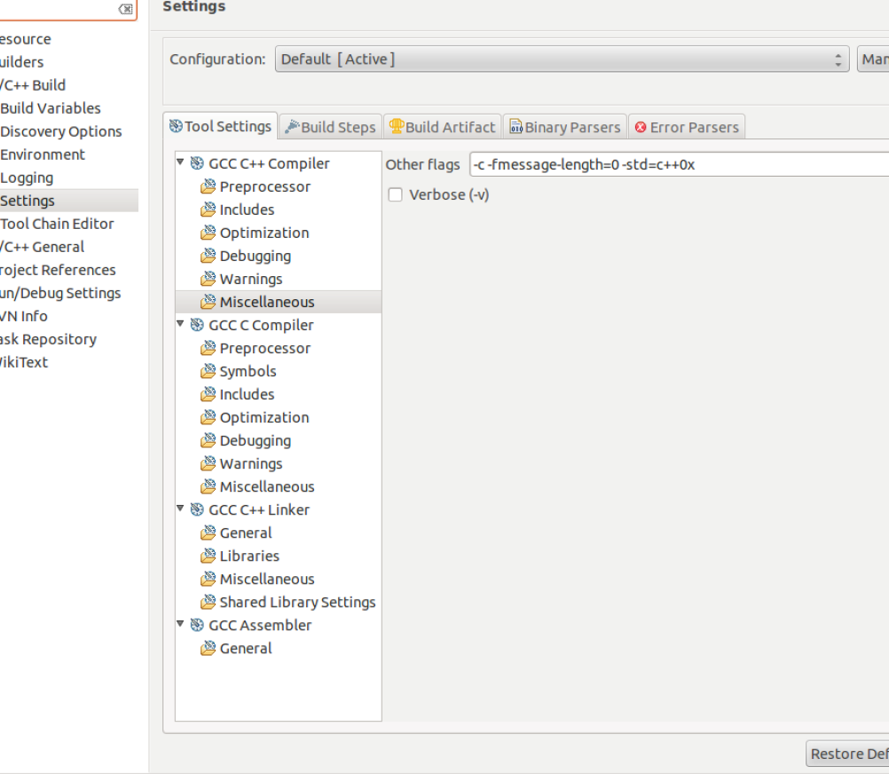

11. Compile your application in Eclipse

12. Create a folder ‘NB_Test’ for the application and copy ‘M1000’ to the folder in your virtual machine

13. Copy ‘scenario.seed_1.dispersal_good.nb_large.json’ to ‘Scenario_Configurations’ folder in ‘NB_Test’

14. Copy ‘seed_1.dispersal_good.nb_large.json’ to ‘Species_Configurations’ folder in ‘NB_Test’ in your virtual machine

15. Edit ‘scenario.seed_1.dispersal_good.nb_large.json’ to match the path of M100 folder.

16. Edit src/main.cpp in Eclipse, lines 60 and 61, point the files to ‘M1000/mask.tif’ (dirty code, need to be modified), and recompile it

17. Create a folder ‘Results’ to save the result.

18. Run the application with the following parameters.

‘root’ ‘json’ ‘result_folder’ ‘max memory usage’ ‘is_overwrite (0:no, 1: yes)’ ‘unused, always 0’

Example:

/home/eesaupe/nb_test scenario.seed_1.dispersal_good.nb_large /home/eesaupe /nb_test/result 8000 1 0